

**100 AVENUE JENKINS, DORVAL, QC H9P 2R1**

**Tel : 514-382-3560**

**jchagnon@airtechni.com**

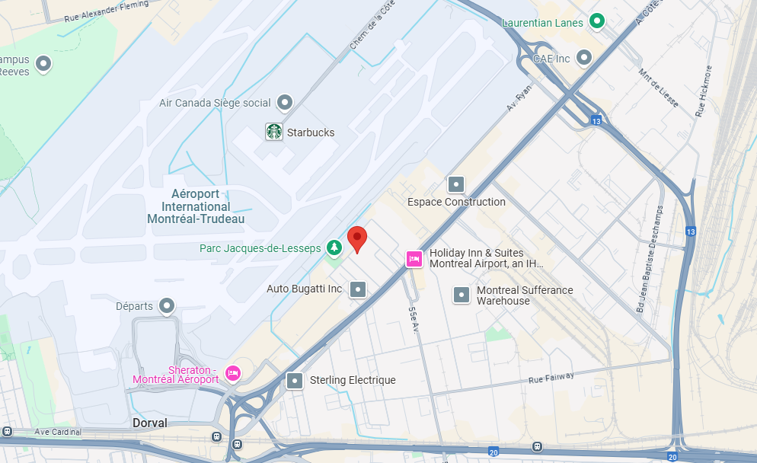

[100 Av. Jenkins - Google Maps](https://www.google.com/maps/place/100+Av.+Jenkins,+Dorval,+QC+H9P+2R1,+Canada/@45.4650507,-73.7500647,14.17z/data=!4m6!3m5!1s0x4cc917d35124fc13:0x692d57f6c890c0e1!8m2!3d45.4622458!4d-73.7292875!16s%2Fg%2F11c23hwxvm?hl=fr-CA&entry=ttu&g_ep=EgoyMDI1MDEyMi4wIKXMDSoASAFQAw%3D%3D)